# MINI PROJECT (2019-20)

**E-Bridge GLAU**

**MID-TERM REPORT**



**Institute of Engineering & Technology**

**Submitted by**

**Ashita Vijay Seth**

**(181500145)**

**Prakhar Singh**

**(181500470)**

***Supervised by:***

**Mr. Neeraj Khanna**

# Department of Computer Engineering & Applications

**Contents**

|  |  |
| --- | --- |
| **Abstract** | **3** |
| **1. Introduction** | **3** |
| 1.1 The Problem Statement | **3** |
| 1.2 Area of Computer Science | **4** |
| 1.3 Hardware and Software Requirements | **5** |
| **2. Objectives** | **6** |
| 3**. Implementation Details** | **6** |
| **4. Progress till Date & The Remaining work** | **7** |
| **5. Some Screenshots** | **8** |
| **6. References** | **21** |

**Abstract**

Currently, we do not have any application to give communication between Teachers and Students by the mobile via messages. Most of the Schools and Colleges are Using Whatsapp as a medium which is considered highly unprofessional.

The major issues were faced during this pandemic, when, the teachers and the students were connected virtually and used WhatsApp as a medium to share things. Whatsapp is a chat-based app used for talking(chatting) with friends and family. Using WhatsApp for academic purposes is not only unprofessional but is also a violation of privacy.

# Introduction

**The Problem Statement**

During this period of pandemic, schools and colleges switched to online sources for providing the study materials to students. Most of the colleges and schools preferred WhatsApp as a communication medium as it is commonly used. But, there are many issues and disadvantages of using WhatsApp which were faced during studying using it. Some of the disadvantages are stated below:

1. WhatsApp is great for personal use. But retrieving messages in a linear chat thread is very difficult.
2. Takes away a lot of productive time of teachers and students by constantly checking messages of not just college/school group but other group as well
3. Have to keep track of incoming doubts and whether they were resolved or not

# Area of Computer Science

## The E-Bridge application is an android application which mainly aims to improve communication between teachers and students. This application actually consists of two modules, those are the Teacher module and Student module, where they can access and operate the application from their respective ends. We focused on both sides which will help both the teachers and the students.

## In general, the Admin will maintain the entire administration like Authorization, Authentication, permissions, History tracking, and troubleshooting, etc.

## The teacher will be allowed to access the academic data of the student. They can send notice and notifications about assignments, deadlines, and other important tasks.

## The application is made extremely user friendly.

## The teacher will access all the four-year student information and go through their Time table as their daily activities as scheduled. They can send or receive any kind of information by using the Notification tab. This will make the tasks easier for the teachers.

## The Student will access all information like Subjects, Faculty, and Schedule, and maintain a good relationship with the faculty and his/her classmates as well. They can send or receive any kind of information like Clarification, Queries, and Notice by using the Notification tab. The student can ask for Doubts in doubt section. Students Profile will provide all the academic information to the teacher.

## In this E-Bridge app Android project, we are proposing a new form of technology to get communication between Teacher and the Student.

## Give Below is the workflow diagram of the project-

Faculty Login

Home Page

Student Login

Student Home Page

Faculty Home page

Sending Notices

(Notification)

Add

Time Table

Sending Doubts

Student data

Adding Question Papers and assignments

Time table

Doubt List

View Important notifications (sent by the faculty)

View and resolve Doubts by students

# Hardware Requirements

* + - System: Intel i3 3rd generation or above
    - Hard Disk: 40GB
    - 1 GB RAM Required(Min.)

**Limitations and Constraints**:

* The Phone must be connected with Internet
* This app can only be installed on android devices

# Software requirements

* + - Any OS
    - Coding Languages: Java, MySQL, php
    - Tool Kit: Android SDK
    - IDE: Android Studio
    - Adobe Illustrator

# Objective

## The main objective of this project is to improve communication between teachers and students. With this project, we aim to provide a professional way to communicate. We will also focus on other aspects like sharing Study Materials, notifications if there is any important information available for them and, easy accessibility.

# Implementation Details

**Part1:**  Creating Home Page which will give us access to the Faculty Login and Student Login.

Part2: Designing the icons needed for the application.

**Part3:** Developing Student Home page which includes asking Doubts, view Time Table, view important notifications sent by the faculty.

**Part4:** Developing Faculty Home Page which includes Resolving and viewing the doubts sent by the students, sending Important notices, adding Timetable, adding question papers and assignments and viewing Student data.

**Part5:** Deploying and Testing the app.

**Progress**

Part 1 is completed (Need Some Changes): We have successfully created the login page of faculty and students and connected it to he Firebase.

Part 2 is completed: we have designed the icons needed for the application which includes- faculty icon, student icon and icons for representing assignments, doubts etc.

Part 3 is ongoing: We are working on Student Home Page.

# SCREENSHOTS

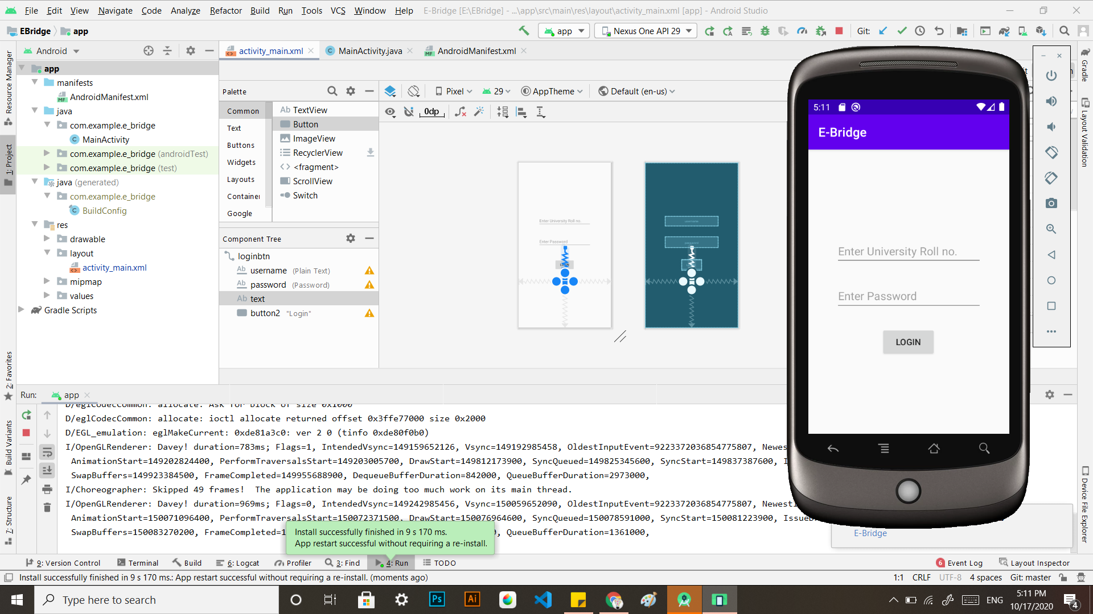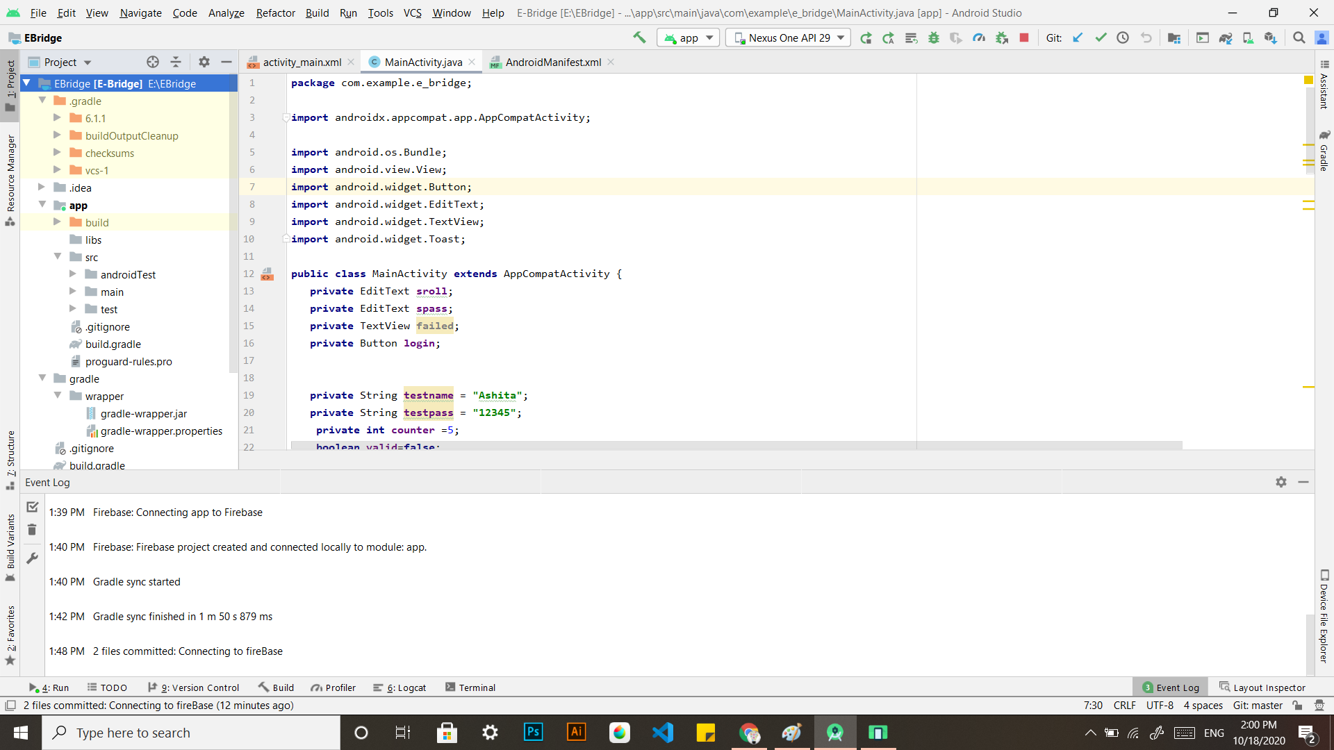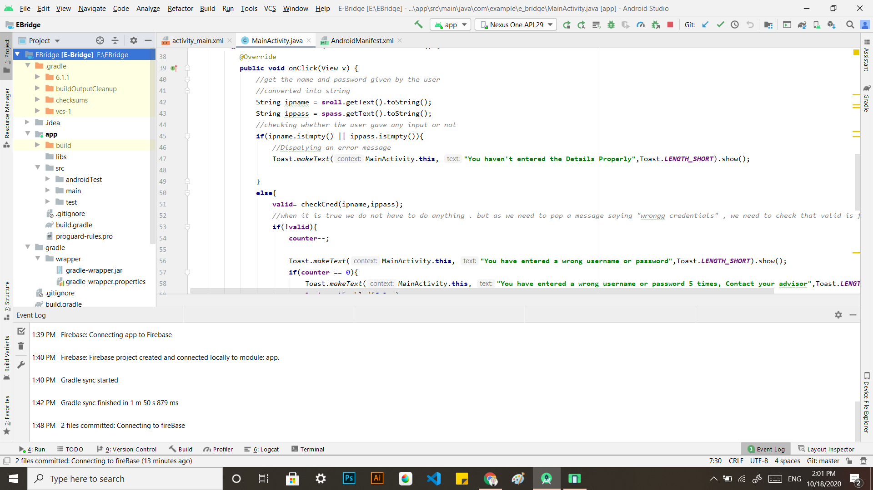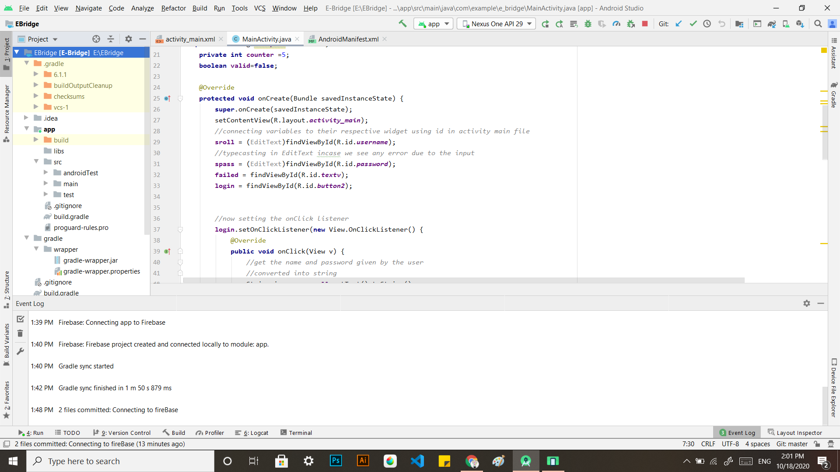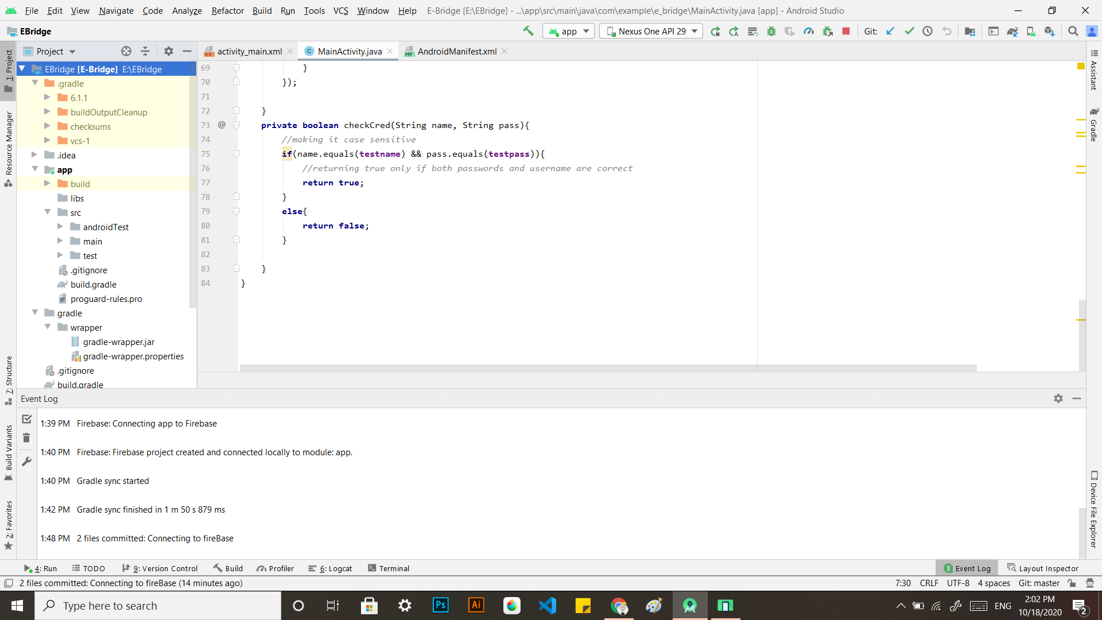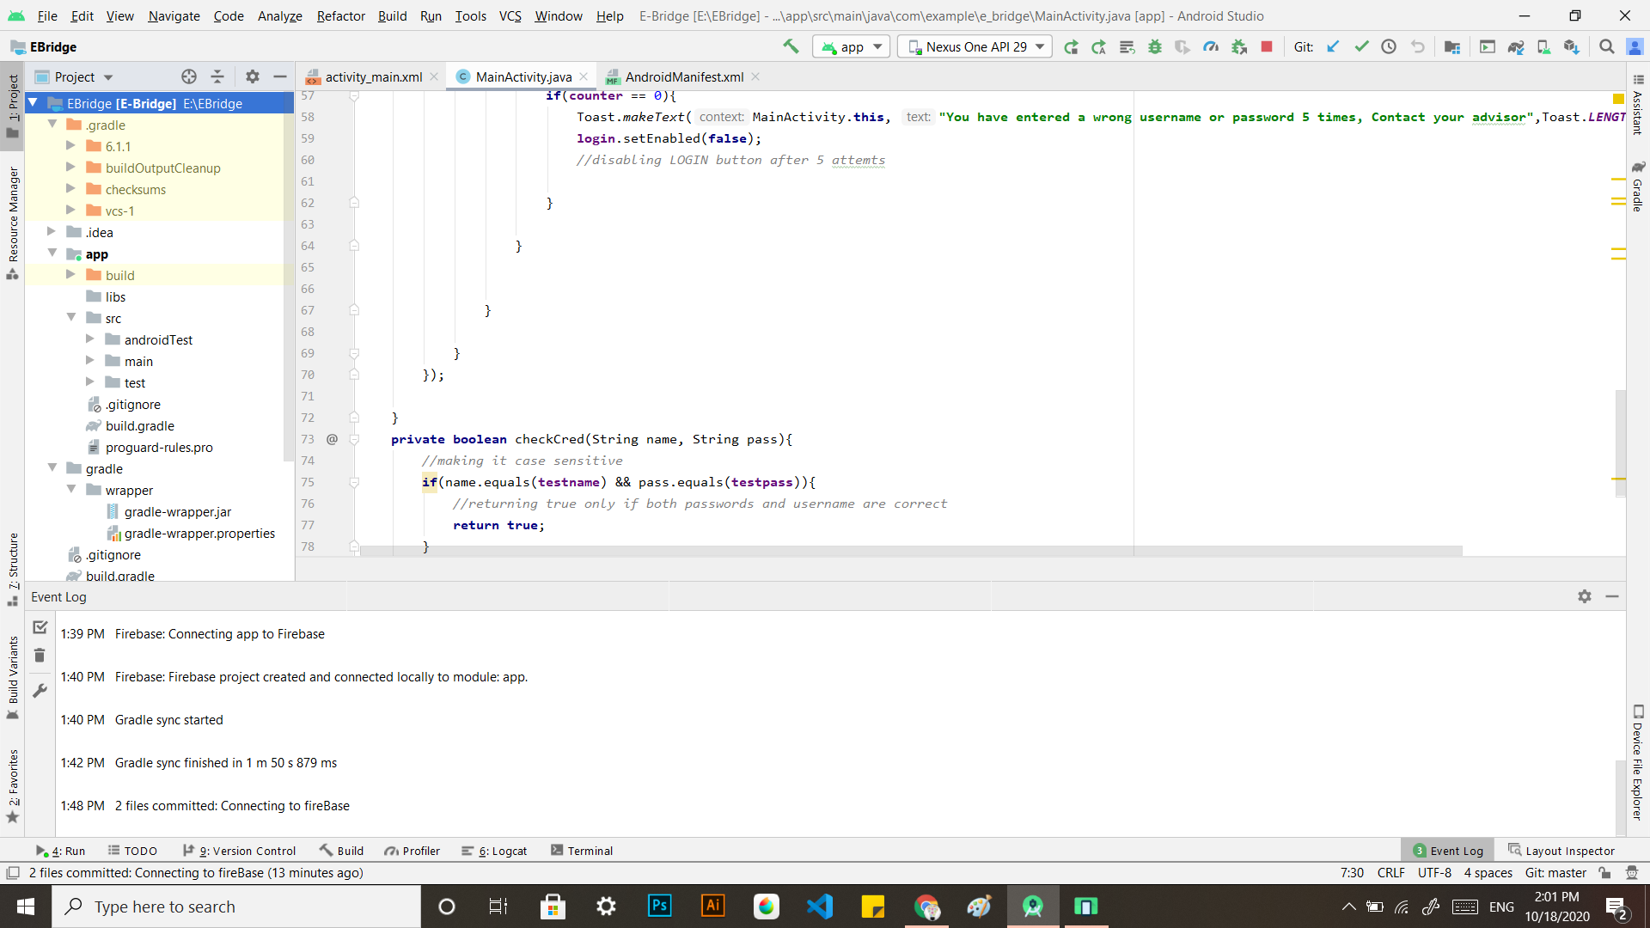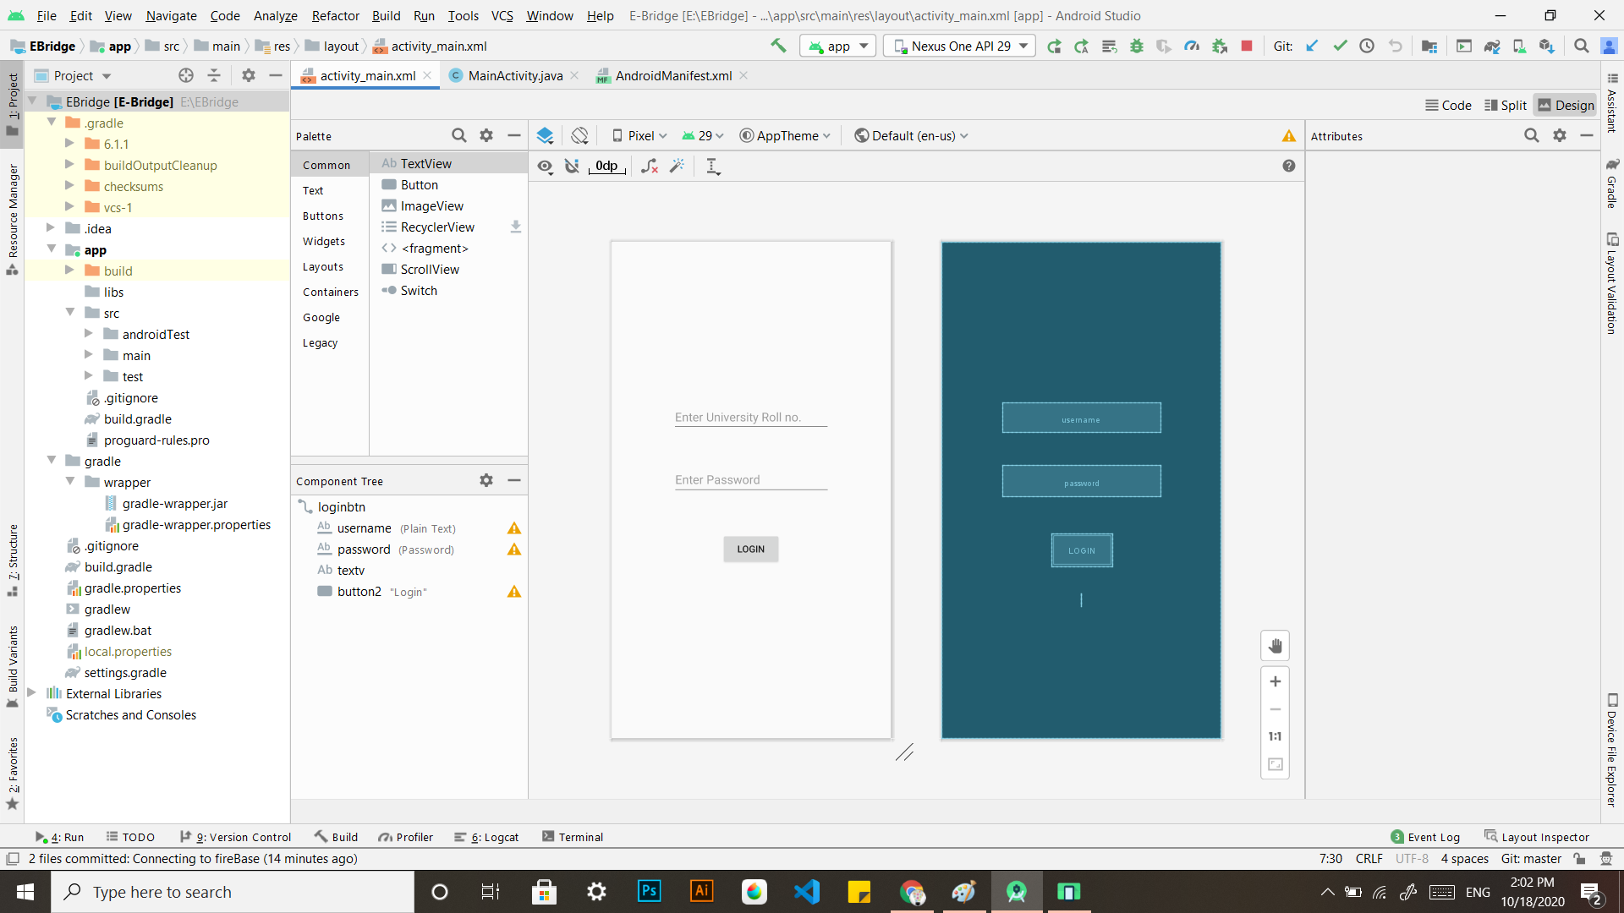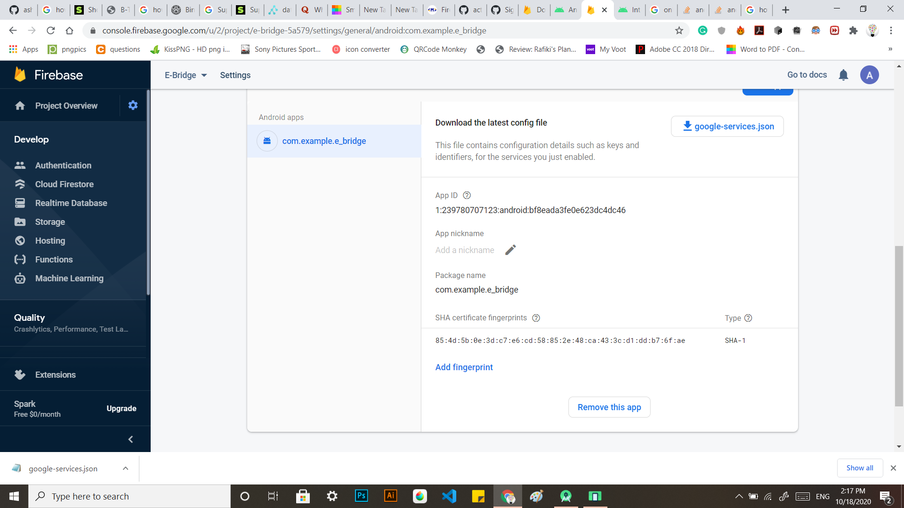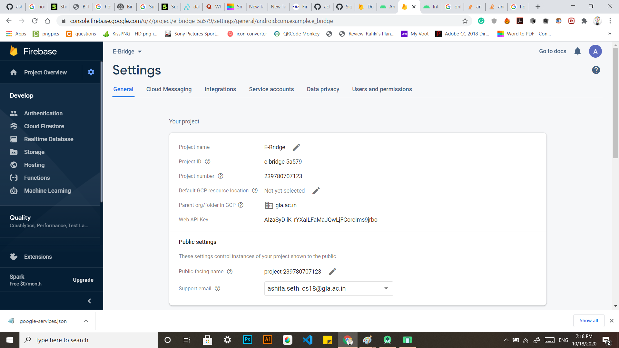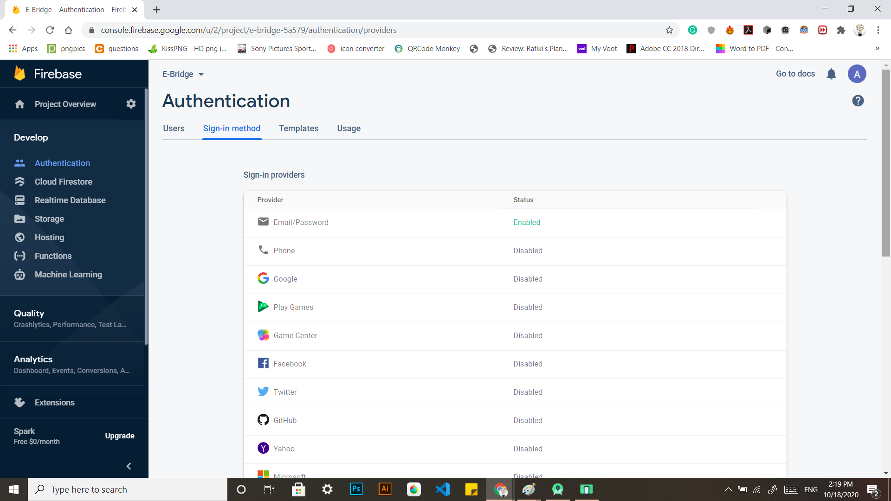



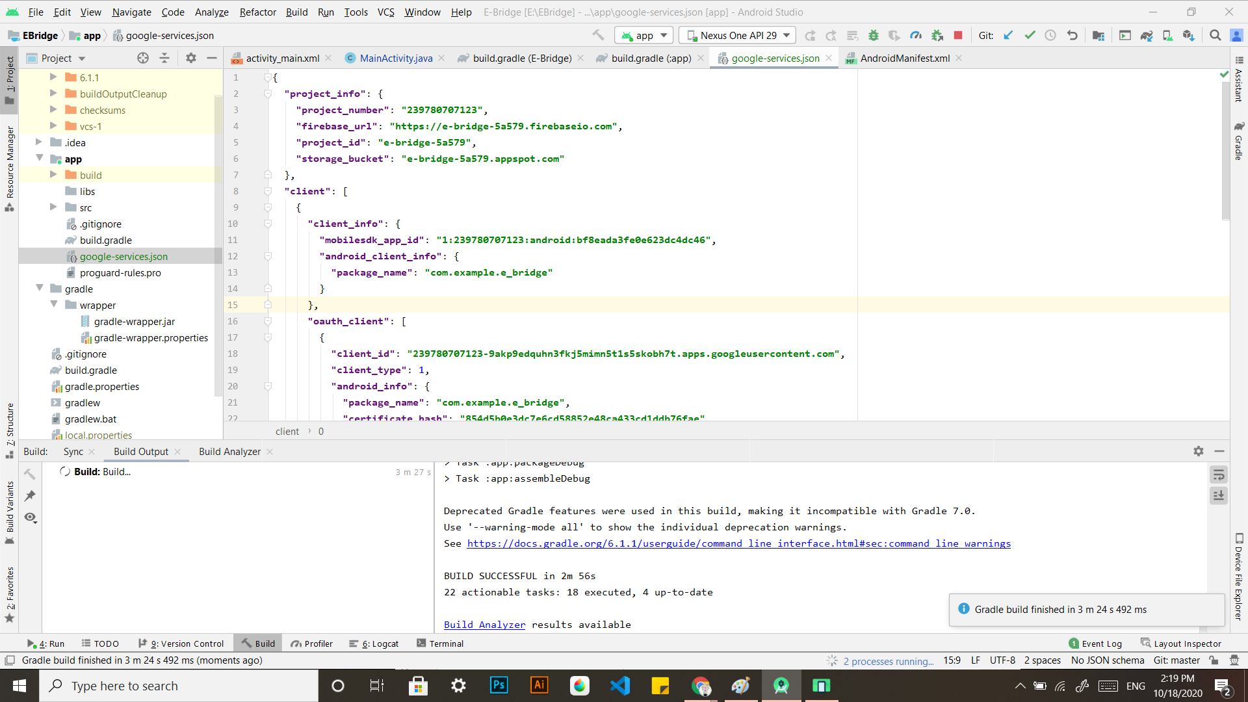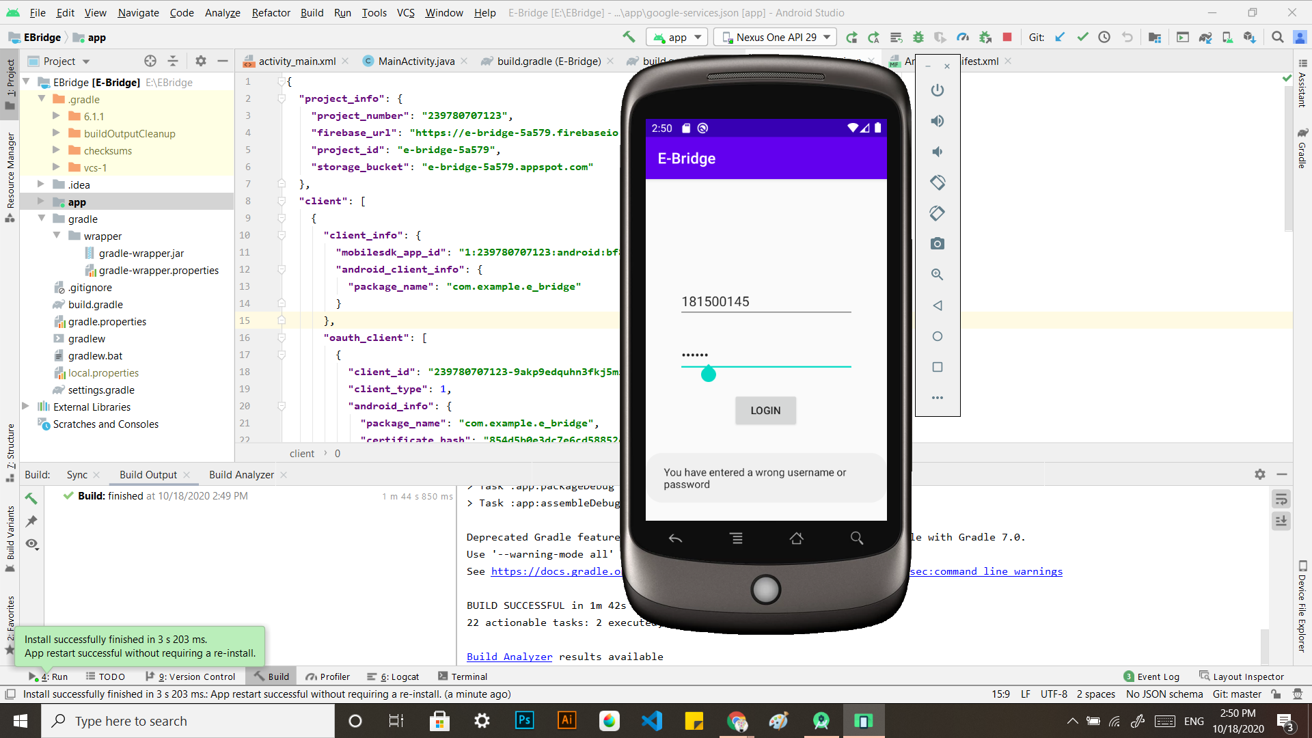

**Screenshots of Icons Designed**

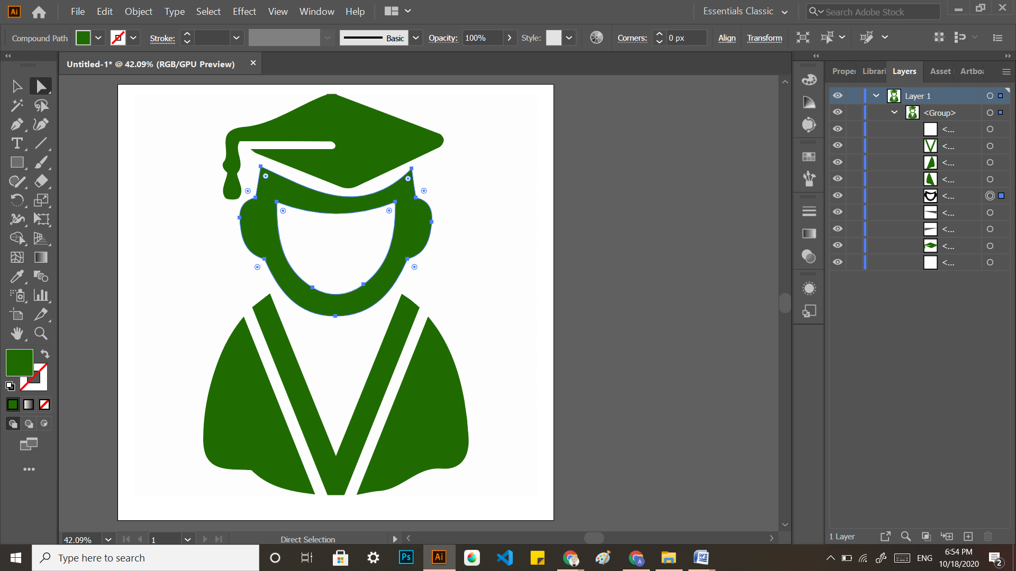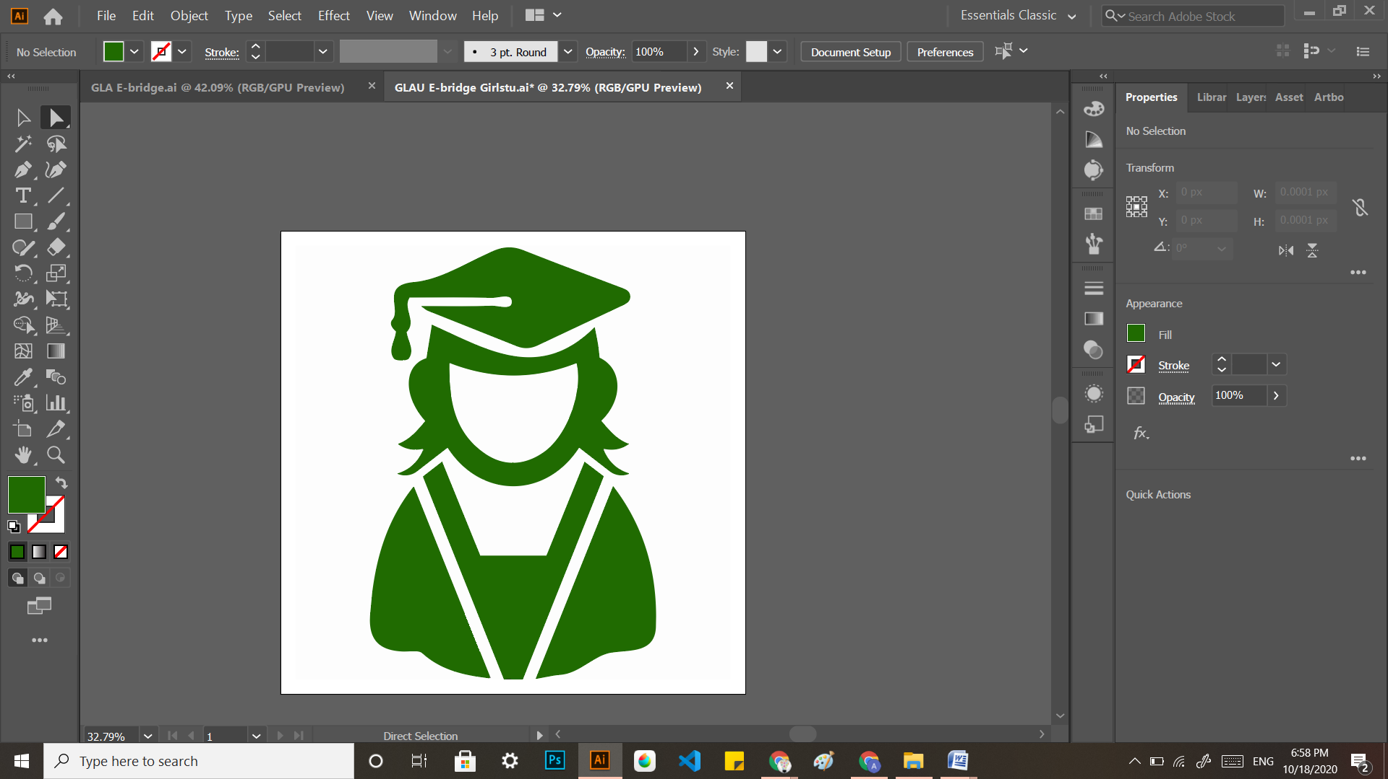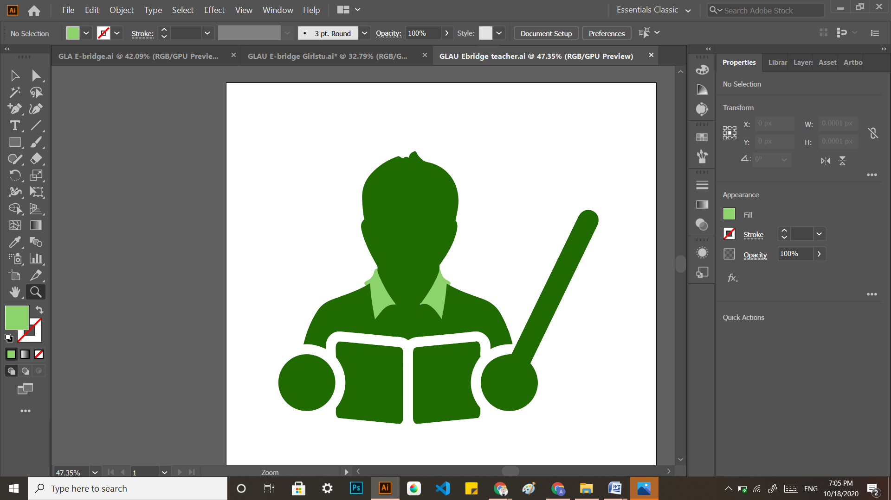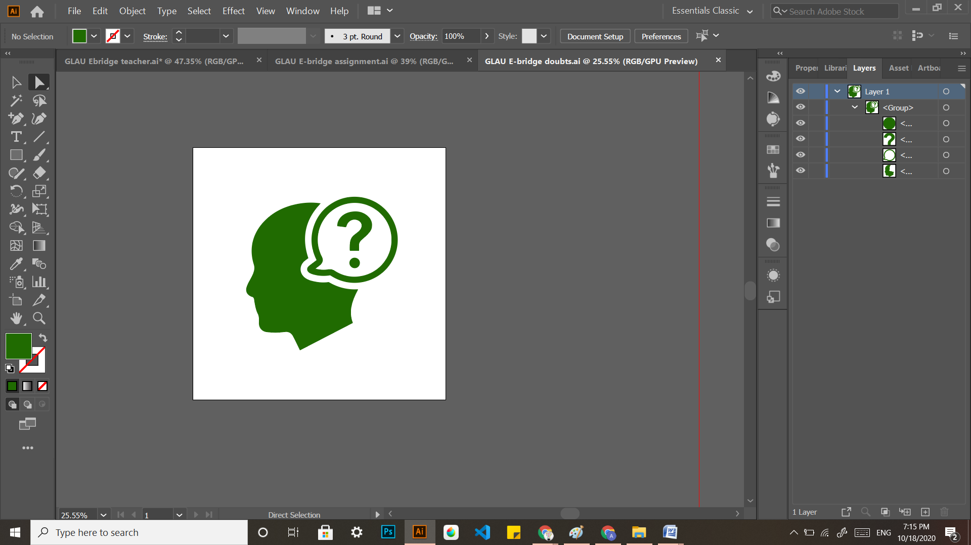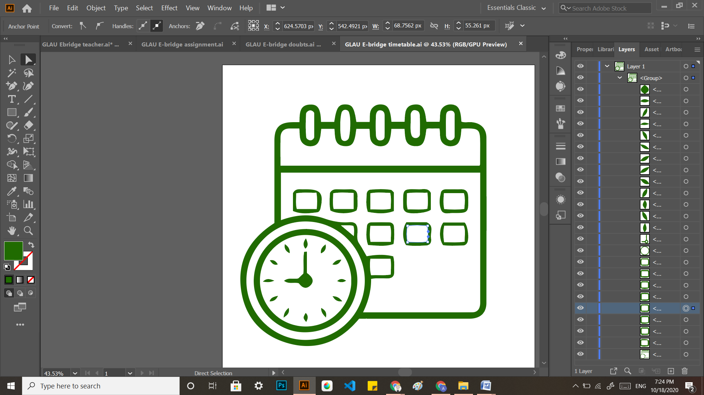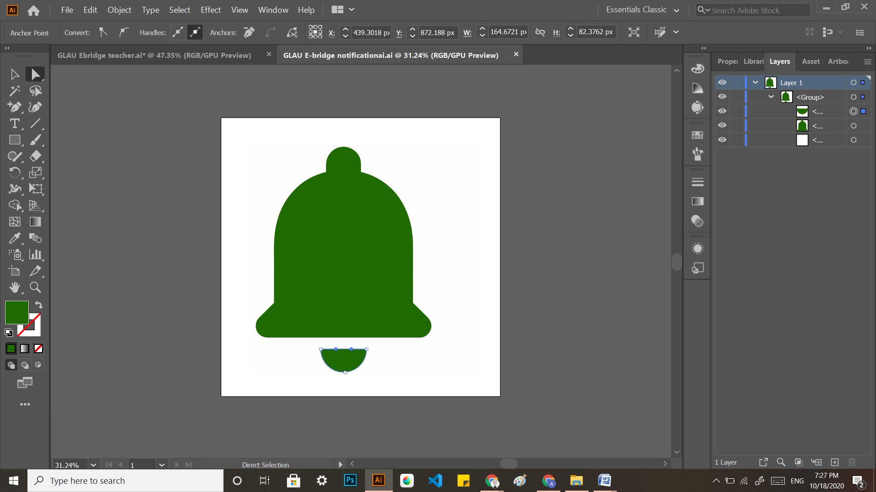

**References**

* + - * <http://blog.onne.world/pros-cons-of-using-whatsapp-for-your-school/>
      * <https://github.com/ashitaseth9454/E-Bridge_GLAU/blob/master/Synopsis.docx>

Certificate of Learning Android Studio

